Single-Image Vignetting Correction Using the Radial Gradient

5/13/2009
CS 638-1 Computational Photography
Patrick Flynn

Abstract

This project is based off of a paper titled “Single-Image Vignetting Correction Using Radial Gradient Symmetry” by Zheng et al. that was submitted to the 2008 IEEE Computer Vision and Pattern Recognition (CVPR) Conference and describes a method to identify and correct images that suffer from vignetting. Vignetting is an effect where the image intensity drops off away from the center of the image, especially in the corners (see Figure 1).
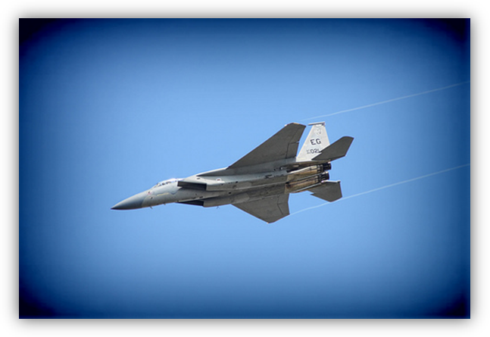
Figure 1: Image with Vignetting
The idea in this paper is that this effect has many radial properties and they use a so-called radial gradient to match an image to a model for vignetting and correct the effect. Using the symmetry of the distribution of this radial gradient the authors can then determine whether or not the image suffers from vignetting and they can correct the vignetting effects by minimizing the asymmetry of this distribution. This algorithm requires no training sets or user interaction.
In this project I implemented the vignetting detection features and attempted to implement one of the correction methods from the paper that tried to fit a model for the vignetting and remove the vignetting from the original image.

Introduction

This project focuses on attempting to correct the effects of vignetting. The three main causes of this distortion are mechanical, optical and natural. The mechanical distortion is caused by the lens rim or some filter that impairs light near the edge of the lens. The optical distortion is caused by the properties of the lens that result in different amounts of light reaching the photoreceptor for different camera / lens combinations. The natural distortion refers the fact that light is not reflected off surfaces equally at all angles and therefore the more oblique the incident angle on the lens is, the less light that reaches the detector. While I focus on removing this effect, vignetting is sometimes added to an image for artistic effect. Due to the intensity drop off at the edges, vignetting draws attention to the center of the image and can be desirable to draw attention to people or objects in the center.

Previous Work

Prior to this paper, there were several previous attempts to model and correct this effect. The first attempts focused on trying to calibrate a camera by either using calibration images where a ground truth was known or by using a series of overlapping images to discern the ground truth and calibrate the camera. While these attempts were successfully in very controlled situations they are not very practical for correcting this effect in a lone image with no prior knowledge of the lens and camera. The next attempts focused on segmenting the image into different regions, correcting the intensity variations in the regions and then rebuilding the whole image. Obviously these algorithms depend on the efficacy of the segmentation algorithms and depend on the uniformity of intensities in a region. A lot of recent work in this area (and other closely related areas) revolves around building some model for the vignetting effects and then remove the vignetting from the pure image. This project’s source paper combines a robust detection feature and a previously developed vignetting model to remove the vignetting effects.

Method

The detection feature the authors used is the symmetry of the distribution of the radial gradient. The radial gradient is just the projection of the normal image gradient along a vector from a point pointing towards the image center. The authors define the radial gradient, , as:
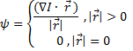
The authors of the paper made the key observation that the distribution of the magnitude of the radial gradient is more or less symmetric for images with no vignetting effects. For images with vignetting however, this distribution is greatly skewed. To define the symmetry of the distribution, the authors use the Kullback-Leibler divergence. If we define:
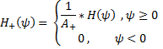
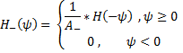
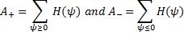
Then the K-L divergence is simply
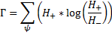
Once the authors sufficiently defined the symmetry measure, they proposed two methods to correct this. The method I chose to implement was their second method, which focused on fitting a model for the vignetting effects. The authors chose to use a simplified Kang-Weiss model for vignetting. If we define our input image as Z, our pure image (output) as I and the vignetting effects as V we get:
The Kang Weiss model defines V as:
The authors of this paper chose to ignore , which is a tilt factor. So I used:
Where
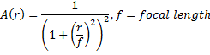
In this paper, the authors used p=5, which they determined by experimentation. Thus to fully determine the model, I had to solve for 6 unknowns, The authors proposed using 3 iterations to determine all of these parameters automatically. The first iteration sets to solve for f. The next iteration fixes f and solves for and the third iteration uses these values as the initial guess into a nonlinear optimization to get our final model. Once this model is determined, the authors simply find I by dividing Z by V.

Implementation

I implemented their method using MATLAB. All of my code will be provided in my hand in directory and I will also put links on the website. I used all of my own code, with the exception of the built-in MATLAB commands as well as the Image Processing and Optimization MATLAB toolboxes.

Unfortunately I was unable to get the correction part of their method to work as I could not get MATLAB’s optimization functions to return anything other than all the parameter values as 0. I will provide my work on this part with the source code, but I do not have any results to show for this.

Results
I was able to successfully implement the vignetting detection portion of this method. Below is a synthetic example of one image that I manually added vignetting effects to in order to see the relationship between the K-L divergence measure and the amount of vignetting.

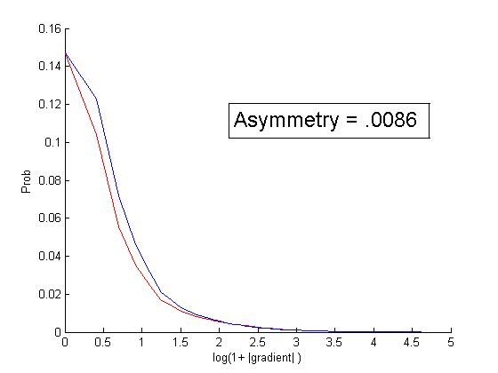
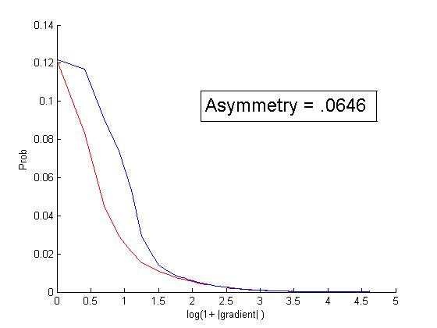
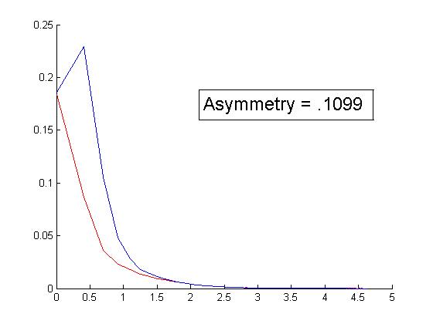
Figure 2: An image with varying vignetting and the corresponding radial gradient distributions

Conclusion
In conclusion, I successfully implemented the vignetting detection feature as proposed by Zheng et al. in their paper presented at the 2008 IEEE CVPR paper. I demonstrated that this feature does accurately describe the level of vignetting in an image by implementing this feature in MATLAB and testing it against several synthetic examples.

References
- Y. Zheng, J. Yu, S. B. Kang, S. Lin, C. Kambhamettu, “Single-Image Vignetting Correction Using Radial Gradient Symmetry”. In CVPR, 2008.

- Y. Zheng, S. Lin, and S. B. Kang. “Single-image vignetting correction”. In CVPR, 2006.

- D. Goldman and J. Chen. “Vignette and exposure calibration and compensation”. In ICCV, 2005.

- Y. Weiss. “Deriving intrinsic images from image sequences”. In ICCV, 2001.

- S. Kang and R. Weiss. “Can we calibrate a camera using an image of a flat textureless lambertian surface?”. In European Conf. on Computer Vision, 2000.

